Economic Impact Payments and
Coronavirus Tax Relief:
A Toolkit for Partners

April 24, 2020

The IRS is working hard to deliver Economic Impact Payments (EIP) as quickly as possible, and we need your help to share important details and outreach materials with your families, friends, partners and clients, posted to your websites, included in your internal newsletters and employee emails and shared on social media.

For additional information, visit IRS.gov.

Economic Impact Payments: Key Items for Partners, Taxpayers

IRS material designed to help taxpayers; Special materials available to share

The IRS is working to deliver Economic Impact Payments as quickly as possible to all eligible Americans. More than 150 million payments will be sent out, and millions of people who normally don’t file a tax return are eligible to receive these payments.

To reach these people outside of the tax system, the IRS is asking for your help to spread the word so more people sign up for these payments worth $1,200 or more. The IRS has created special information and graphics that you can use, share and adapt in your constituent communications, including material suitable for emails, newsletters, web sites and other channels.

To help navigate this, the IRS has created this special Partner Toolkit. Here’s an overview of key resources to help you and your family, friends, partners and clients. The IRS asks for your help sharing this important information:

Overview of Economic Impact Payments (EIP): IRS.gov has a special page that allows individuals, businesses and others get the information they need about EIP and CARES Act provisions.

Common Questions: The IRS is seeing a variety of questions about Economic Impact Payments, ranging from eligibility to timing. These FAQs provide an overview and are updated frequently. Common questions for which guidance is available are also included in this Toolkit with direct links to the answers online.

“Get My Payment” Tool Tracks Payments, Helps with Bank Account Information: The IRS designed a new tool called “Get My Payment” to help people track the status of their payments, similar to the “Where’s My Refund?” tool used during tax season. Some taxpayers who don’t have a scheduled payment date can provide direct deposit payment on this app to speed their payment.

“Get My Payment” questions and “Status Not Available”: To help taxpayers understand the “Get My Payment” tool and the results, we have an extensive set of FAQs online at IRS.gov. We encourage people to review these. For the “Status Not Available” screen that taxpayers get on the “Get My Payment” tool, there are several reasons they may receive this. The FAQs will continue to be updated online as necessary, and common questions for which guidance is already available are included in this Toolkit with direct links to the answers online.

Help for people who don’t normally file – Use the “Non-Filers: Enter Payment Info” tool: Millions of Americans aren’t required to file a tax return, but they’re still eligible for an Economic Impact Payment. This includes people with little or no income, retirees, homeless and many others. To help these groups quickly register for a payment, the IRS created the special “Non-Filers: Enter Payment Info” tool, available only on IRS.gov.

- People using the “Non-Filers: Enter Payment Info” tool only need to provide basic information, including their Social Security number, name, address, and dependent information. The IRS will use this information to confirm eligibility and calculate and send their Economic Impact Payment – helping millions of people who don’t normally file a tax return.
- Not sure if “None-Filers: Enter Payment Info” is right for your situation? The IRS has provided examples to help determine when they need to use this tool.

Payments Automatic for People Who Filed Tax Returns in 2018 or 2019: For eligible taxpayers who filed tax returns for 2019 or 2018, they will also receive the payments automatically. About 80 million payments started hitting bank accounts in mid-April. More are coming each week.

Payments Automatic for Many Federal Beneficiaries – SSA, SSI, RRB and VA: Following extensive work by the IRS and other government agencies, $1,200 automatic payments will be starting soon for those receiving Social Security retirement, survivor or disability benefits (SSDI), Railroad Retirement benefits, Supplemental Security Income (SSI) and Veterans Affairs beneficiaries who didn’t file a tax return in the last two years. No action is needed by these groups; they will automatically receive their $1,200 payment.

Urgent: Special Action Needed by Federal Beneficiaries with Dependents: For those benefit recipients who aren’t required to file a tax return and who have children, an extra step is needed to add $500 per child onto their automatic payment of $1,200. A quick trip to a special non-filer tool on IRS.gov is need. SSI and VA recipients in this category who act by May 5 can put all of their eligible Economic Income Payment into one payment. The April 22 deadline has passed for SSA and Railroad retirees. Those who miss these deadlines can still receive $500 when they file a 2020 tax return next year.

Help Us Share Information; Special Materials Available on IRS.gov: To help share information with your family, friends, partners and clients, we have a variety of ready-to-use materials available in English and Spanish. These are available at Economic Impact Payments: Partner and Promotional Materials. You can use and adjust these materials as you need, including:
- IRS e-posters and Twitter images that can be used on websites, social media, newsletters and other platforms.
- Print materials include Tax Tips, short, plain English summaries of EIP, and “Ready to Use” articles that can be shared with family, friends, partners and clients in emails, newsletters and web sites.

Share information in Social Media; share IRS accounts: The IRS will be regularly sharing Economic Impact Payment information on social media. Share or like these to help spread the information to taxpayers:
- Twitter: Taxpayers, businesses and tax professionals can follow the IRS handles for up to the minute announcements, tips and alerts in English and Spanish.
- Facebook: News and information for everybody. Also available in Spanish.
- Instagram: The IRS Instagram account shares taxpayer-friendly information.
- YouTube: The IRS offers video tax tips in English, Spanish and American Sign Language.
IRS: Working Across the Nation with Partner Groups. The IRS is conducting a sweeping outreach campaign across the nation to reach everyone who may be eligible for an Economic Impact Payment. Helps us with this effort. Share this information with family, friends, partners and clients. Contact us if you have additional groups you’d like us to share information with.

These images and others are available for your use with your partners, employees and other. Get copies at www.IRS.gov/EIPpartners.
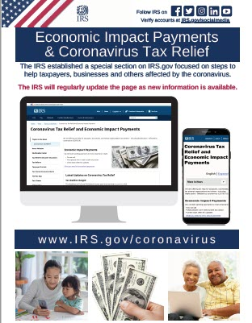

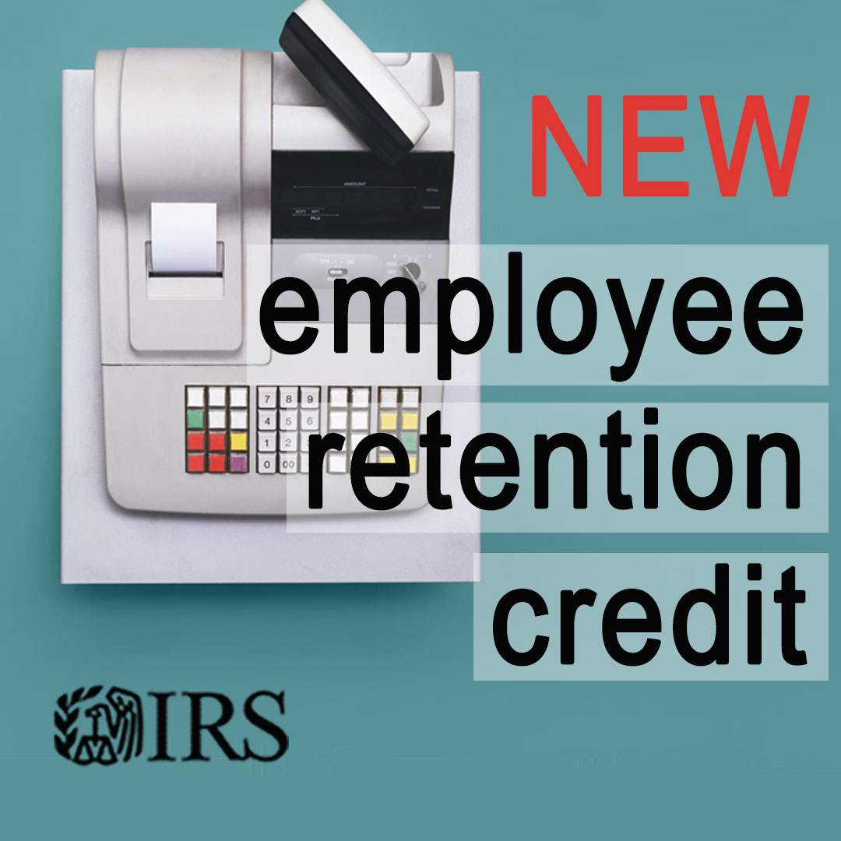
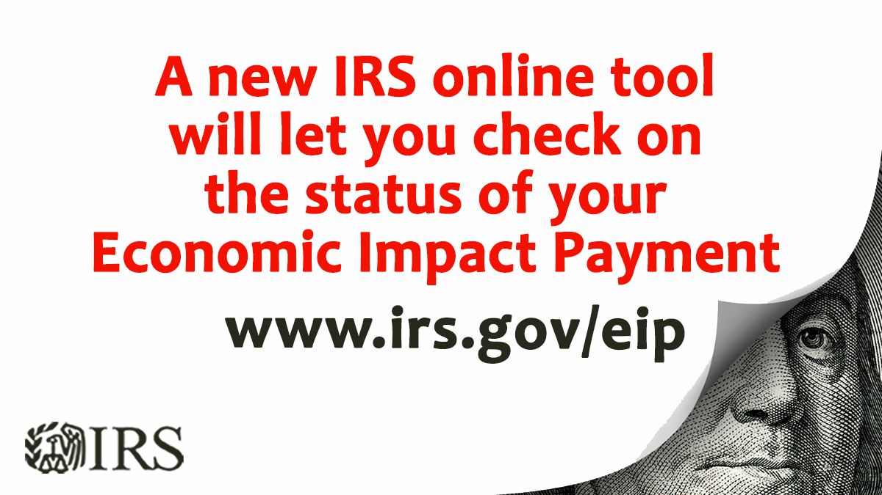

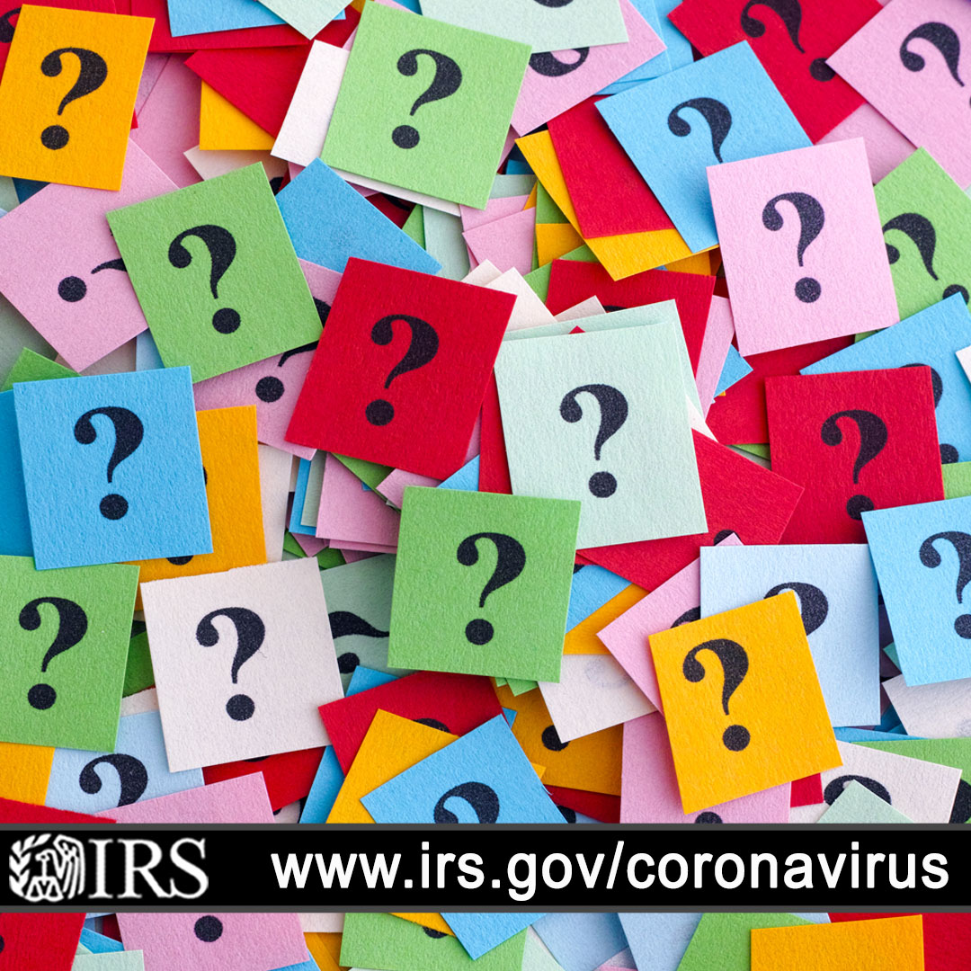

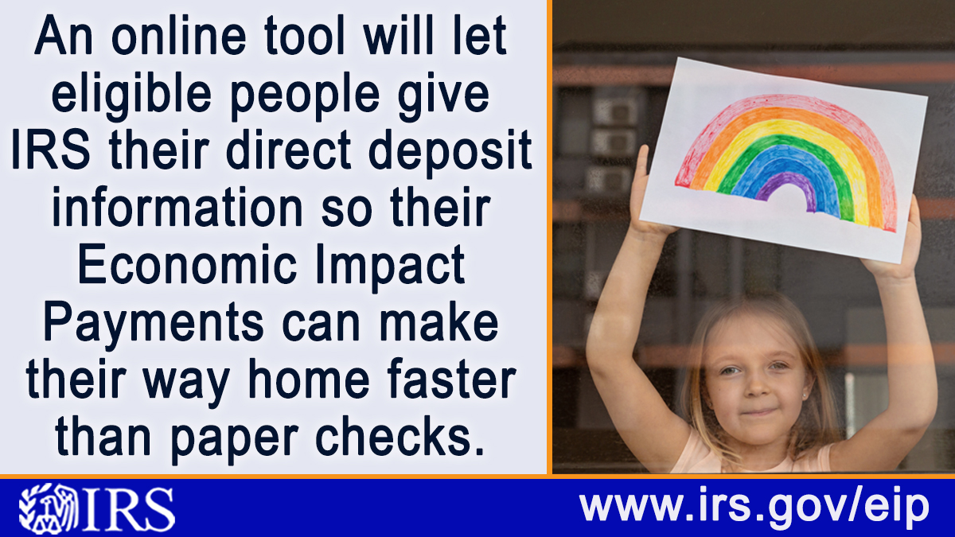

Table of Contents

Economic Impact Payments: Key Items for Partners, Taxpayers 2

Additional Details Related to EIP, CARES Act and Coronavirus 7

Status of IRS Operations: Mission-critical functions continue 8

Information for Individuals and Families 8

Information for Businesses and Tax-Exempt Entities 8

Information for Health Plans and Retirement Plans 9

People First Initiative 9

FAQs Related to CARES Act, EIP and coronavirus 9

Economic Impact Payment FAQs 10

Get My Payment FAQs 12

Additional Details Related to EIP, CARES Act and Coronavirus
The IRS is continuing to add information every day related to these measures. The latest information is available on IRS.gov, where a special page has been established for these items.

The following information presents an overview of material available on IRS.gov through the date of this publication. For the most recent information, please check the web site.

Economic Impact Payments

We started distributing Economic Impact Payments in April. Most people will get their payments automatically and will not need to take any action. Social Security, Railroad Retirement, SSI and VA beneficiaries who are not typically required to file tax returns will not need to file to receive a payment. Instead, payments will be automatically deposited into their bank accounts. The IRS is currently unable to answer questions about payment status over the phone, but individuals can check the status of a payment online.
Check your payment status.

EIP: Partner and Promotional Materials

To help share information with your family, friends, partners and clients, we have a variety of ready-to-use materials available in English and Spanish. These are available at Economic Impact Payments: Partner and Promotional Materials. You can use and adjust these materials as you need, including

Tax Tips

Ready-to-Use Articles

Posters and Other Partner Materials

Social Media

Partner Materials/Public Service Announcement
- Economic Impact Payments & Coronavirus Tax Relief Special Section on IRS.gov — e-Poster (PDF)
- Economic Impact Payments for Social Security, Railroad Retirement and Social Security Disability Insurance recipients — e-Poster (PDF)
- If you still need to file — e-Poster (PDF)
- IRS social media & e-News — e-Poster (PDF)
- Economic Impact Payments — e-Poster (PDF)

Status of IRS Operations: Mission-critical functions continue
While we continue to process electronic returns and issue refunds, some IRS services are limited. Get up-to-date status on affected IRS operations and services.

Information for Individuals and Families

Filing and Payment Deadline Extended

The deadlines to FILE and PAY federal income taxes are extended to July 15, 2020.
Answers to your questions on the filing and payment deadline.

Coronavirus-Related Paid Leave for Workers
Many Americans are entitled to paid sick leave, either to tend to your own health needs or to care for a family member, under the Families First Coronavirus Response Act.
Read the press release on paid sick leave.

Information for Businesses and Tax-Exempt Entities

Filing and Payment Deadline Extended
The deadlines to FILE and PAY federal income taxes are extended to July 15, 2020.
Get answers to your questions on the filing and payment deadline.

Employee Retention Credit Available for Many Businesses Financially Impacted by COVID-19
The Employee Retention Credit is a refundable tax credit against certain employment taxes equal to 50% of the qualified wages an eligible employer pays to employees after March 12, 2020, and before January 1, 2021. You can get immediate access to the credit by reducing the employment tax deposits you are otherwise required to make. Also, if your employment tax deposits are not sufficient to cover the credit, you may get an advance payment from the IRS.

Get details on the retention credit.

Coronavirus-Related Paid Leave for Workers and Tax Credits for Small- and Mid-Size Businesses

The Families First Coronavirus Response Act (PDF) gives all American businesses with fewer than 500 employees funds to provide employees with paid leave, either for the employee's own health needs or to care for family members.
Get details on paid leave for employees.

Information for Health Plans and Retirement Plans

High-Deductible Health Plans
High-deductible health plans (HDHPs) can pay for 2019 Novel Coronavirus (COVID-19)-related testing and treatment, without jeopardizing their status.
Read the press release on HDHPs

More Information
See all Frequently Asked Questions, resources and guidance.

People First Initiative
New People First Initiative; COVID-19 effort temporarily adjusts, suspends key compliance program. The IRS has taken a number of steps to address a variety of audit and compliance questions during the coronavirus.
IRS News Release IR-2020-59

FAQs Related to CARES Act, EIP and coronavirus

Links to the many FAQs available on IRS.gov are provided below. The IRS is continually updating these FAQs as new questions arise or further guidance is available. Additionally, questions for which guidance already is available are listed below, with direct links to answers online.

Frequently Asked Questions
- Get My Payment Frequently Asked Questions
- Economic Impact Payment Frequently Asked Questions
- Temporary procedures to fax certain Forms 1139 and 1045 due to COVID-19
- Estate tax Form 706 deliveries returned due to COVID-19
- Deferral of employment tax deposits and payments through December 31, 2020
- Installment agreement direct debit FAQs
- COVID-19-related tax credits for required paid leave provided by small and midsize businesses FAQs
- Employee Retention Credit under the CARES Act
- Department of Labor: Families First Coronavirus Response Act: Questions and answers
- Filing and payment deadlines questions and answers

Economic Impact Payment FAQs

Eligibility

Q1. Who is eligible to receive a Payment?

Q2. Will I receive a Payment if I do not make enough money to normally have to file an income tax return?

Requesting My Economic Impact Payment

Q3. I recently filed a tax return. What do I need to do to get a Payment?

Q4. I haven’t filed a tax return for 2018 or 2019 and don’t need to file tax returns for those years. I receive Social Security, SSI, or Railroad Retirement benefits. What do I need to do to get a Payment?

Q5. I haven’t filed a federal tax return for 2018 or 2019 and don’t receive Social Security retirement or any other federal benefits. What do I need to do to get a Payment?

Q6. I did not file a tax return for 2018 or 2019. How do I know if I am required to file a tax return?

Q7. I receive veterans benefits. Do I need to provide information to the IRS or file a tax return to receive a Payment?

Q8. Who should NOT use Non-Filers: Enter Payment Info Here?

Q9. I need to file a tax return but am concerned about visiting a tax professional or local community organization in person right now to get help with my tax return. How long is the Payment available?

Q10. Will the IRS contact me about my Payment?

Calculating My Economic Impact Payment

Q11. What is the amount of the Payment I will receive?

Q12. What is the amount of my Payment if I haven’t filed a tax return for 2018 or 2019 and am receiving an automatic Payment based on benefits that SSA or RRB paid me in 2019?

Q13. Will my Payment be reduced if my income is too little or too much?

Q14. I filed a joint return with my spouse. Will we receive a Payment if I have a valid SSN and my spouse has an IRS Individual Taxpayer Identification Number (ITIN)?

Q15. What is meant by a valid SSN required for a Payment?

Q16. Is a child born, adopted, or placed into foster care in 2020 a qualifying child for the Payment?

Q17. I received an additional $500 Payment in 2020 for my qualifying child. However, he just turned 17. Will I have to pay back the $500 next year when I file my 2020 tax return?

Q18. I claimed my child as a dependent on my 2019 tax return. She is graduating from school in 2020. Will she receive her own Payment?

Q19. I claimed my mom as a dependent on my 2019 tax return. Will I receive an additional Payment for her or will she receive her own Payment?

Receiving My Payment

Q20. Is the Payment taxable as 2020 income?

Q21. If I owe tax, or have a Payment agreement with the IRS, or owe other federal or state debts, will my Payment be reduced as an offset?

Q22. How will the IRS know where to send my Payment?

Q23. What if the bank account number I used on my recent tax return is closed or no longer active? Can I switch and be mailed a Payment?

Q24. I already filed my 2019 tax return and owed tax. I scheduled a Payment (electronic funds withdrawal, Direct Pay, or Electronic Fund Transfer Payment System (EFTPS)) from my bank account. Will the IRS send my Payment to the account I used?

Q25. I already filed my 2019 tax return, but I didn’t provide bank information. Can I use the Non-Filers: Enter Payment Info Here tool to provide my banking information?

Q26. How do I find the bank account information the IRS needs?

Q27. What if I don’t have a bank account?

Q28. My address is different from the last tax return I filed. How can I change my address?

Q29. Where did you get the bank information for me, and what if I need to change it?

Q30. I requested a direct deposit of my Payment. Why are you mailing it to me as a check?

More About the Economic Impact Payment

Q31. As a U.S. citizen living abroad, am I entitled to a Payment?

Q32. If I live in Puerto Rico, the U.S. Virgin Islands, American Samoa, Guam, or the Commonwealth of the Northern Mariana Islands, will I get a Payment if I’m eligible?

Q33. Will I get the Payment if I am not a U.S. citizen, U.S. permanent resident, or a resident of these territories?

Get My Payment FAQs

EIP Eligibility and General Information

Who is eligible?

Who is not eligible?

How much is it worth?

Do I need to take action?

Payment recipients: watch for an IRS letter

Avoid scams related to economic payments, COVID-19

Should I use Get My Payment or Non-Filers: Enter Payment Info Here?

Accessing Get My Payment

When can I start checking Get My Payment for the status of my payment?

If I filed jointly with my spouse, does it matter whose information I use for Get My Payment?

I am not required to file a tax return, can I still use Get My Payment to check my payment status?

I receive a Form SSA-1099 or RRB-1099 and file a tax return. Can I use Get My Payment to check my payment status?

I receive a Form SSA-1099 or RRB-1099 and do not file a tax return because I don’t meet the income requirement to file. Can I use Get My Payment to provide my bank information to receive my EIP by direct deposit?

If I have an Individual Taxpayer Identification Number (ITIN), can I use Get My Payment?

Payment Status

How long will it take for my payment status to change?

Does Get My Payment display different stages of my payment?

Payment Status Not Available

Why am I getting "Payment Status Not Available"? (updated April 17, 2020)

Bank Account Information

Where did the IRS get my bank information, and what if I need to change it?

My bank account information has changed since I filed. Can I update it using the tool?

I no longer have the bank account that I used for direct deposit on my tax return. Can I change it using Get My Payment?

I used direct deposit to split my refund between several accounts when I filed my tax return. Can I use Get My Payment to designate which account I want my payment deposited in?

I made an electronic payment from my bank account to the IRS (includes a Direct Debit Installment Agreement (DDIA)). Will my payment be direct deposited to the same account? Can I use Get My Payment to provide my bank account information?

What does it mean when Get My Payment says, "Need More Information"?

Can I use Get My Payment to check the direct deposit status if I changed my payment method to direct deposit?

If Get My Payment is unavailable, will Where’s My Refund or View Your Account allow me to provide my bank information?

Locked/Status Unavailable

What does it mean when Get My Payment says, "Please Try Again Later"?

Why can't I get my payment status?

Will Where’s My Refund or View Your Account provide my payment status?

Error Message

Why am I receiving an error message when answering the security questions?

Address Changes

My address is different from the last tax return I filed. Can I change it using Get My Payment?

I requested a direct deposit of my payment. Why are you mailing it to me?

I requested a direct deposit of my payment. Why are you mailing it to me?

These images and others are available for your use with your partners, employees and other. Get copies at www.IRS.gov/EIPpartners.
